THE GLADIOLUS
Game Design

Group Members
Taha Işıklar
Hacer Yenişar
Hakan Asmaoğlu
Onur Kenar
Nüket Aziz
Artem Kryvitskyi

Consultant Name: Yard. Doç. Dr. OZAN AĞLARGÖZ

Eskişehir Anadolu University
Faculty of Communication Sciences
December,2016
1.STORY(Name, logo and slogan of the game!)
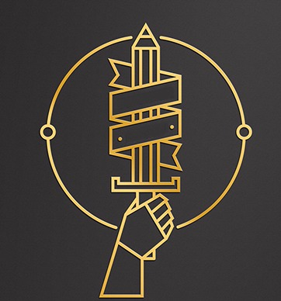
‘’Game logo.’’
THE HOSTIA
Crede,Parta,Belli ! (Believe,Won,War)
There was ongoing war the beginning of which was unknown in the world where the islands were in the sky and oceans in the earth. According to some people, the reasons of the war were reaching and stealing the stars.
In the midst of all this war, famine and death the child was born whose eyes were as bright as the stars in the sky, hair was white as the moon and body as small as handful. Everyone thought that this child would die before reached the first year because his body was so small. Howewer, the child has resisted this fate and begun to smile, run and play. But one day, the moon in the sky was red and as soon as the child entered his 5th year, hundreds of children in the country have disappeared. When they all opened their eyes, they realized that the walls were as hard as iron, the place was so cold and a pair of red eyes were looking at them. Suddenly, it has yelled at the children:
‘’Since right now, I am both your past and your future.’’
The red-eyed man has made the children be stuck on himself before they started to cry. Children have forgotten their past and the red-eyed man said that he would write their future. The reasons for this were need of gentle and the ambition to believe that the man was born to conquer. The powers of the man have had a limit, it was increasing as the planets conquered, but at the same time it was making him suffer. The pain of the man was so increased. As a result, the man has become unable to use the powers he had obtained. One day, the man learned a secret on a planet which he had just conquered. According to Sahitar (His soothsayer):
‘’This new conquest planet is sacred, my lord. The children here are born with a great magic power. When children reach the age of 16, their special powers emerge in the ceremony. When ceremony starts, a great magic power shows up and children transform pure energy for an instant with this great magic power. As the ceremony is over, a tattoo appears in the children’s body and this tattoo is a symbol of their power. If we can steal their power during these ceremonies, you will have your former glory thanks to this energy you have earned.’’
The plans proceeded as they asked. As the war continued with all the power, it was the ceremony time for the first kidnapped child. The first child was brought to the ceremony area and the ceremony was held. When the tattoo is about to emerge, the red-eyed man took all the power. At least he thought he had all the power.
The red-eyed man was victorious in all the planetery wars but suddenly he felt worse than he used to be. He immediately went to his palaca and searched the cause of it, but the result did not please him. According to Sahitar, the energy was right and stil circulated in the man’s body but this power was in the same direction as he received from other planets and because of it’s purity, the power was increasing for a moment.
Suddenly, the red-eyed demon raged but could not move because of the pain he had. Sahitar continued to talk :
‘’There is one more way, my lord. As we know, there is a different power on this planet than the powers of other planets. People who live here can heal themselves but some of them can do it much faster. During the ceremony, if we can find the right child you will have your former glory forever. ‘’
Drakthar (Red-eyed devil) has become increasingly weak and and he has never left his palace for a while. He was less interested in war and he began to take more care of the children. The children were sacrificed to the ceremony every year but the Drakthar did not reach a conclusion. The children that Drakthar has were about to run out and other children could not enter the ceremony because they were sealed by planetery owners. Drakthar could not stop the war in this world because of his pain, even though he had a moment of instant power.
When the other children grew up, they began to remember their past and Drakthar was not able to take hold of them. First, the white-haired boy is awake. He witnessed the devil's evil and the murder of his friends. Over time, only 12 children remain. Sahitar had a last idea. Drakthar and Sahitar decided that the last 12 children would attend the ceremony. The ceremony began when the last child reached 16 years of age. When children transform pure energy for an instant with this great magic power,Drakthar took their power and realized the change in his body so that he thought that he reached the right child. Suddenly, the doors of the palace have collapsed and people living on the planet have begun to come in. They have walked toward the children and Drakthar.
As the devil distracted, he acted to save his friends. It is at this moment that Satan does not have time to finish the ceremony. Drakthar could take half of the powers and the children, the army and Sahitar were taken to another dimension by Drakthar. But he made a big mistake because of his carelessness. In this new world, there was a divergency between the children and Drakthar. Drakthar was trying to arrest the children and complete the ceremony, the children were trying to establish kingdoms against the devil by combining their powers. The purposes of Drakthar were taking his former glory and conquering this new planet but the children were trying to return their old planet and get stronger to end this war and defeat the devil.
Now let me be one of the children in this alien world and strengthen yourself. Defeat the evil ruler and his men.Be a great empire owner.

2. ABOUT THE GAME SYSTEM
Our game is a game we can play both at home and on the phone. Games can be transferred between the phone and computer. There are different ways to collect different jobs and money for these two. In this way, the player is provided with tools for developing a wide range and enjoying more.
3. WHEN STARTİNG THE GAME
Select Nickname
Select Gender: Male/Female
We choose the design of our character (Clothes, hair, eye color etc.)
Select powers for character: There are 12 powers in the game. Fire, water, earth, air, ice, electricity, volcano, light, dark, crystal, mud and fog. These forces are divided into attack and defense. We will choose two powers. We can choose an attack and a defense force.
Advantages of attack forces
1.Fire: Rival takes fire and continuously damaged.
2.Water: Enemy start to slow down and can’t move.
3.Electricity: Enemy enters shock and can’t move.
4.Volcano: Rival takes fire and can’t move.
5.Light: Enemy enters shock and the enemy becomes blind.
6.Dark: Enemy enters shock and the enemy becomes blind.
Advantages of defense forces
1.Earth: The character will not be damaged for a while.( Because it turns into soil.)
2.Air: The character will not be damaged for a while.( Because it turns into air.)
3.Ice: The character will not be damaged for a while.( Because it turns into ice.)
4.Crystal: The character will not be damaged for a while.( Because it turns into crystal.)
5.Mud: The character will not be damaged for a while.( Because it turns into mud.)
6.Fog: The character will not be damaged for a while.( Because it turns into fog.)

WEAPON
Weapons are 3 kinds. Siege weapons, provide space to capture. Single weapons(Remote War&Close Combat) are for far and near single fighting.
Siege Weapon:
It is the kind of weapon that we can use when defend our castle or capture the castles. (For example; catapult, cannon, wheeled tower)
Remote War Weapons:
Weapons that characters use individually. (For example; arrow, crossbow, stick of magician)
Close Combat Weapons:
Weapons that characters use individually. (For example; knife, sword, shield, spear)
When the game is open/ Purpose of the game:
An auxiliary character appears in the upper left corner. This character directs you to a certain level. The character chooses her/his profession and starts to trade. When the character reaches level 20, he/she can join any guild or he/she can establish his/her own guild. Various tasks are performed and wars are made to go to the next level. The task of the character is overcoming devil by strengthening himself/herself.

‘’This is our auxiliary character. We chose this because the game needs to be up to date.’’

4.INFORMATION ABOUT TASKS
Character performs training tasks between levels 1-5. When the character reaches level 5, he/she chooses his/her profession and begins to fulfill his/her professional tasks. The tasks are divided into two groups. Physical tasks and mental tasks. Mental tasks are the tasks that the player can do without standing up. It is in the form of questions and answers and is based on the general culture. Pysical tasks are active tasks that the player should perform at a certain distance.
Physical Tasks
With phone:
The task of opening a box on foot.(Box: Suprise game items box.)
‘’Suprise box!’’
Collecting goods.(Goods: Collecting items on the periphery.)
With computer:
In-game tasks that we will perform by moving our character through the game. Our character in these missions the game tries to do the duties it gives them. These missions are usually given when the game has missed every level In addition to this, the character can take on the tasks of the in-game people.

Mental Tasks
Duties in the form of question and answer.
For example:
1. The Library of Celsus in Ephesus was built by...
A) Romans
B) Greeks
C) Ottomans
D) Anatolians Answer: ‘’A’’
2. The capital of the Golden Horde is...
A) Sarai Batu
B) Batu
C) Kiev
D) Kurultai Answer: ‘’A’’
3. The official religion of the Kievan Rus’ is...
A) Christianity
B) Islam
C) Hinduism
D) Confucianism Answer: ‘’A’’
4. Who was the God of music, poetry, art, oracles, archery, plague, medicine, sun, light and knowledge in Greek mythology?
A) Apollo
B) Sol
C) Luceus
D) Zues Answer:’’A’’

‘’Characters on these tasks, earn gaming money or goods.’’
5.PROFESSIONS
When the character reaches the level 5, he/she can choose two of the following professions. Each professions have its own organization and these organizations facilitate trade between each other.
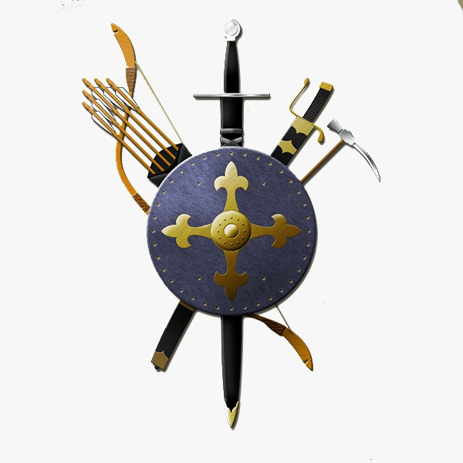
‘’In-game career choice symbol.’’
1) Animal Husbandry:The characters have the right to have some animals when he/she reaches level 20. Those people who make this profession train these animals for a fee.
2)Farming:Farmers collect grasses that provide additional features to the players. Also farmers provide raw materials to other occupational groups.
3) Blacksmithing:The hammersmith is responsible for processing the mines in the map. He/she communicates with other professional groups and the obtained mines are processed.
4) Sailors: They are the units needed for the transportation and security of the sea.
5) Alchemist: It is a unit that produces pots that allow characters to renew their lives and their mana. It takes raw materials from other profession groups and turns them into life and mana pot.
6) Miner: He/she is responsible for finding the mines that hammersmith will process.
7)Mercenary: They are responsible for preserving the caravan that on the road. Also it is a unit that steals or protects goods.
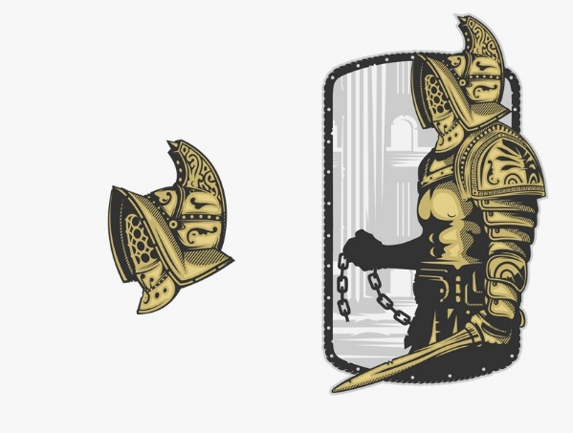
‘’Mercanary symbol!’’

+ If you choose to protect, you will receive money to protect the sent caravan.
+ If you choose to steal, attack the caravan and if you are successful you will gain money and property.

6.NPC(Non Player Character)

Estate Agent-Lessee: In the game characters can capture certain places by fighting. They can make money by renting this place to somebody else. The rented person also earns money from here.
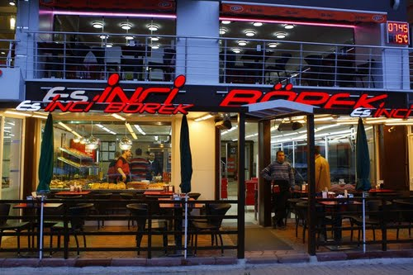
‘’For example:’’İnci Börek’’. If we have it here, we can rent it(!)’’
Beggar: It appears randomly in any part of the map. It gives various equipment that the player needs in return tasks or questions and tells them where those equipments are located.

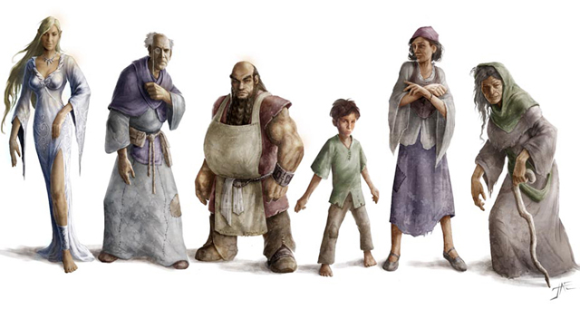
‘’Beggars can go into various costumes.’’
7.GUILD
It is the type of unity that the players create when they reach level 20. It is also a type of organizations that help to capture and defend any place.
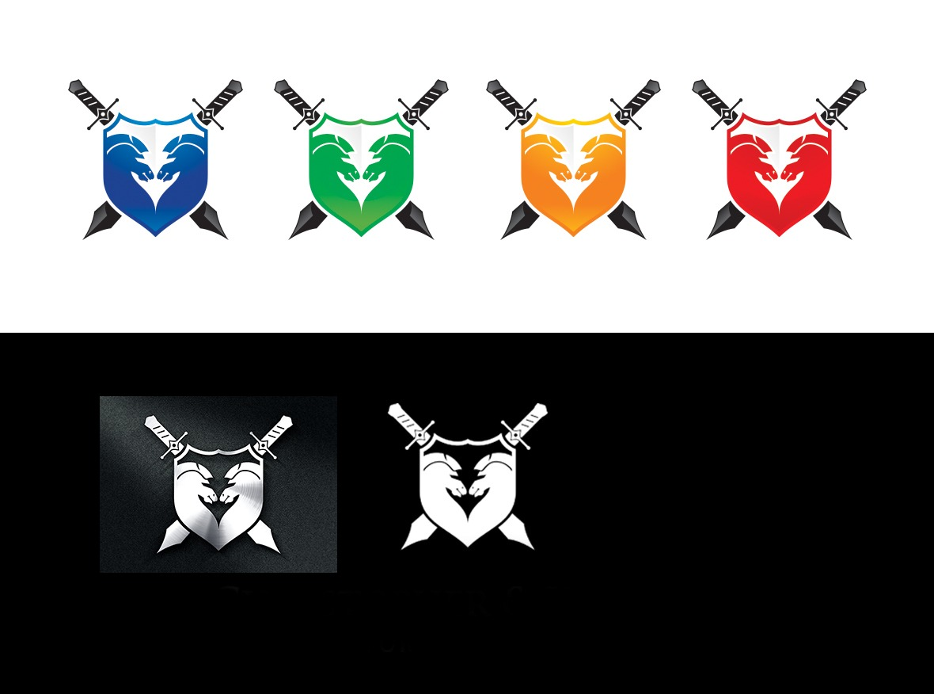
‘’ Symbols of the clans.’’

8.TRADING SYSTEM
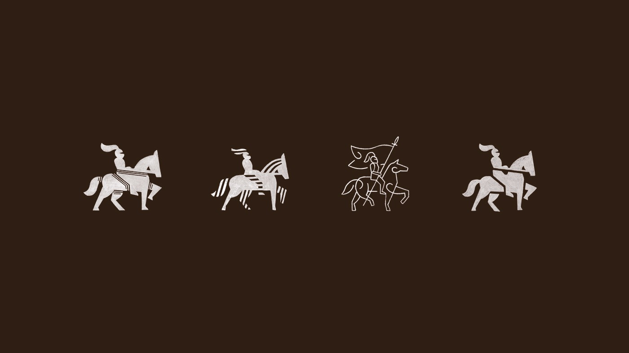
‘’Trading system symbol.’’
1) Sending Caravan
It is a game system that allows players to trade with their friends to earn Money.
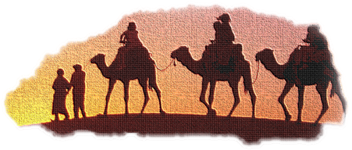
If the distance we will send the caravan is long, we may prefer pegasus instead of camel.
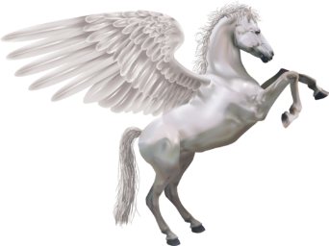
2) Purchase and Sale of Equipments
It is a system that allows players to buy and sell items they win.
3) Conquering of Area
It is a game system in which the loncas conquer certain areas and earn money and items.
4) Lessee
Unlike the conquering the areas, it is the game system in which player acquire Money and items by seizing certain points.
5) Money System
It is the Money system that is made by depositing real Money into the game. Unlike other games, these products are only for visuals and allow you to skip levels quickly. There is no obvious difference between players.
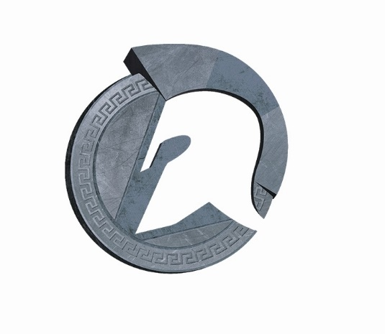
‘’In-game money symbol.’’
9.SPECIAL EVENTS
1) Ponchics Rain :
This activity is specific to the game. At the end of the level, when the monsters are defeated by the players (eg Medusa), it is a game system that rains on the winning characters and gives a random items.
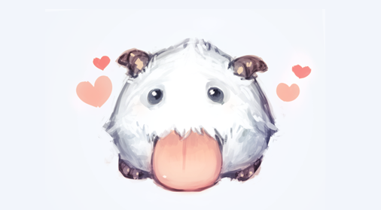
‘’This is a Ponchic’’
2) Special Days
The players are given various features by the producers on birthdays, festivals and other special days. There are various activities on these days.
10.ABOUT THE COMMUNICATION SYSTEM
Providing interaction between characters. Provides messaging between each other.
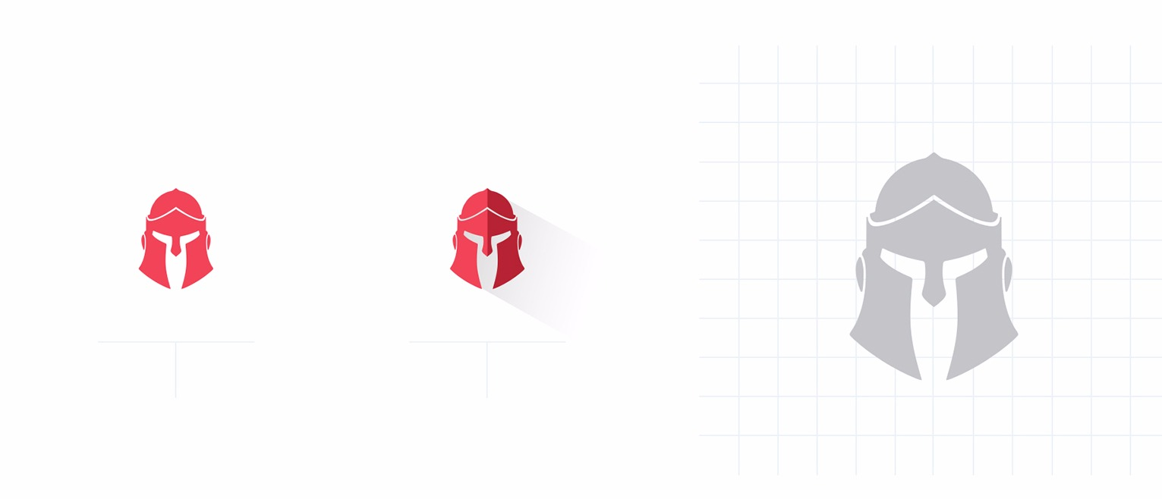
These symbols indicate that the character is active or inactive for communication. If the sign is red, we say that we are active in the game, that the reaction can respond. If the sign is grey, we say that we are inactive in the game, that the reaction can’t respond.
11. Capture System
Characters can capture certain places to earn money. Some places are captured with the guilds, while others can be captured by a single character. More money and goods are earned than places captured by the guild.(For example: Yılmaz Market, İnci Börek, Espark)
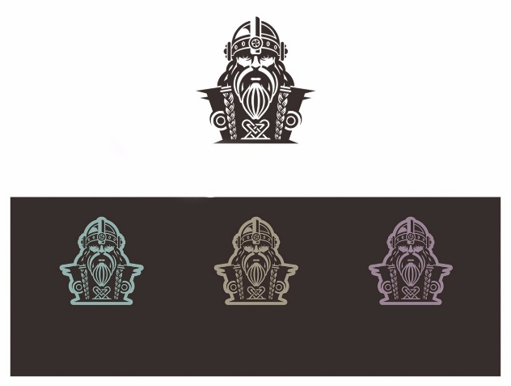
The places to be taken consists of 4 colors:
White: That's the seizeable territory.
Turquoise: You must fight alone to seize.
Purple: You must fight with guild to seize.
Dark-brown: You can’t capture.
REFERENCES (For photos)

https://ak1.ostkcdn.com/images/products/10449663/e.l.f.-10-piece-Mystery-Box-df684bed-1ee6-464c-90c6-41e715fab7fb_600.jpg

http://orig14.deviantart.net/b5c5/f/2013/123/3/7/poro1_by_justduet-d63wx6c.png

https://mrpsmythopedia.wikispaces.com/file/view/pegasus-B.png/566453127/537x402/pegasus-B.png

https://cataloguingshadows.files.wordpress.com/2014/11/dmxp_067-illo-1.jpg

http://mw2.google.com/mw-panoramio/photos/medium/48978995.jpg

